

|  |
| --- |
| PSG COLLEGE OF TECHNOLOGY Innovation Practices  Functional Specification Document   Document Management System |

**FINAL DOCUMENT**

**Table of Contents**

1. Introduction 4

1.1 Purpose of the document 4

1.2 Project Scope 4

1.3 Scope of the document 4

1.4 Related documents 4

1.5 Terms/Acronyms and Definitions 4

1.6 Risks and Assumptions 4

2. System/ Solution Overview 5

2.1 System Actors 5

2.2 Dependencies and Change Impacts 5

3. Functional Specifications 6

3.1 User Management ..………………………………………………………………………………………………………………….6  
 3.2 Document Management ..…………………………………………………………………………………………………………6  
 3.3 Access Control ..………………………………………………………………………………………………………………………..6  
 3.4 Compliance Management …………..………………………………………………………………………………………….. 6  
 3.5 Search and Retrieval ..…………………………………………………………………………………………………………….. 6  
 3.6 Audit Trails ..……………………………………………………………………………………………………………………………. 6

4. Other System Requirements/ Non-Functional Requirements 7

4.1 Performance …………………………………………………………………………………………………………………………….7  
 4.2 Scalability …………………………………………………………………………………………………………………………………7  
 4.3 Security …………………………………………………………………………………………………………………………………….7  
 4.4 Availability ……………………………………………………………………………………………………………………………….7  
 4.5 Usability ……………………………………………………………………………………………………………………………….….7

5. Integration Requirements 7

5.1 Exception Handling/ Error Reporting 7

Appendix 7

# Introduction

## Purpose of the document

This document defines the functional specifications for the Document Management System (DMS). It serves as a guide for developers, stakeholders, and project managers to ensure the system meets business requirements for efficient and secure document handling.

## Project Scope

The Document Management System is a **web application** designed to provide businesses with a secure platform for storing, organizing, and managing documents. The system will include role-based access, document versioning, and compliance management while ensuring an intuitive user experience.

## Scope of the document

This document details the requirements, design considerations, and use cases for implementing the Document Management System.

## 1.4 Related documents

* System Architecture Document
* Project Charter

## 1.5 Terms/Acronyms and Definitions

* **Metadata:** Additional information about a document (e.g., author, tags).
* **RBAC:** Role-Based Access Control, a security mechanism for restricting system access to authorized users.
* **Versioning:** Maintaining a history of changes to a document.

## 1.6 Risks and Assumptions

* Risks: Potential delays in implementation due to budget constraints.
* Assumptions: Users have basic knowledge of web applications and file management systems.

# System/ Solution Overview

## 2.1 System Actors

* Admin
* Editor
* Viewer

## 2.2 Dependencies and Change Impacts

* *Dependencies: Integration with existing authentication systems.*
* *Change Impacts: Modifications to existing workflows.*

# Functional Specifications

## 3.1 User Management

## Role-based authentication and access control.

## User account creation, modification, and deactivation.

## User data includes: Name, email, role, contact information, and permissions.

## 3.2 Document Management

## Upload, store, and organize documents in folders or categories.

## Support for multiple file formats (e.g., PDF, DOCX, XLSX).

## Automatic versioning to maintain a history of changes.

## Document tagging for easy categorization and search (e.g., project name, department, status).

## 3.3 Access Control

## Define roles (e.g., Admin, Editor, Viewer).

## Assign permissions at folder or document level.

## Prevent unauthorized downloads or edits.

## 3.4 Compliance Management

## Configure data retention policies (e.g., archive after 5 years, delete after 10 years).

## Generate compliance reports for audits.

## 3.5 Search and Retrieval

## Optimized Search: Search by document name, tags, or metadata (examples: "Project A," "Finance Report").

## Sorting: Filter results by date, type, or size for efficient retrieval.

## Performance: Minimize search time with indexing and caching techniques.

## 3.6 Audit Trails

## Log user activities such as uploads, edits, and deletions.

## Generate access reports for specific documents or users.

# Other System Requirements/ Non-Functional Requirements

**4.1 Performance**

The system should handle a large volume of documents efficiently and ensure minimal delays in search or retrieval.

**4.2 Scalability**

The system should scale to accommodate an increasing number of documents and users as the business grows.

**4.3 Security**

* Strong encryption for data storage and transmission.
* Regular security updates and vulnerability testing.

**4.4 Availability**

The system should maintain 99.9% uptime during business hours.

**4.5 Usability**

The system should be intuitive and user-friendly, requiring minimal training for basic operations like uploading, searching, and organizing documents.

## 5. Integration Requirements

## 5.1 Exception Handling/Error Reporting

* Generate logs for system errors.
* Provide detailed error messages to aid in troubleshooting.

# Appendix

**OneDMS Screen Outputs**

**Home Page**

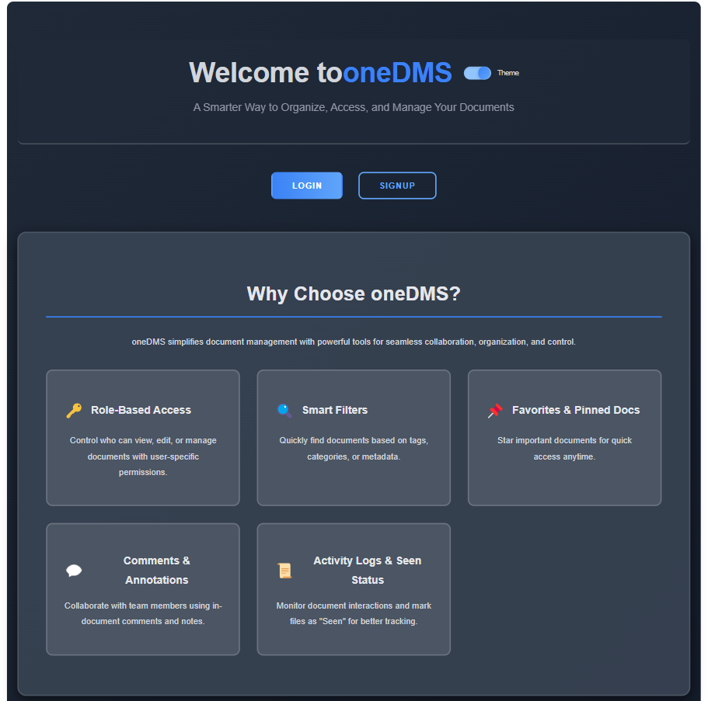 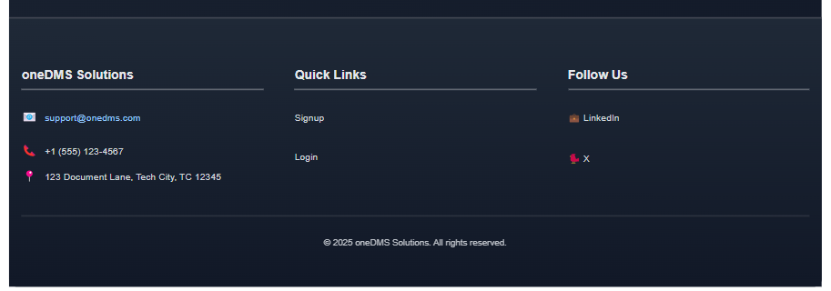

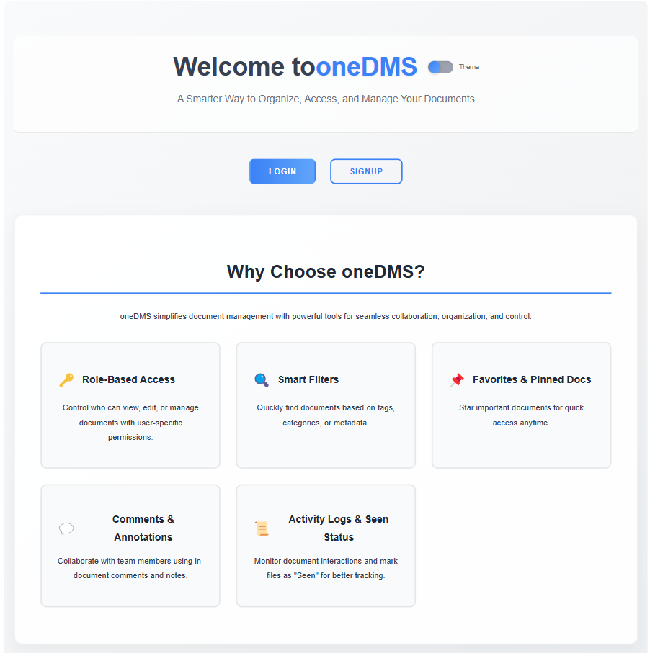 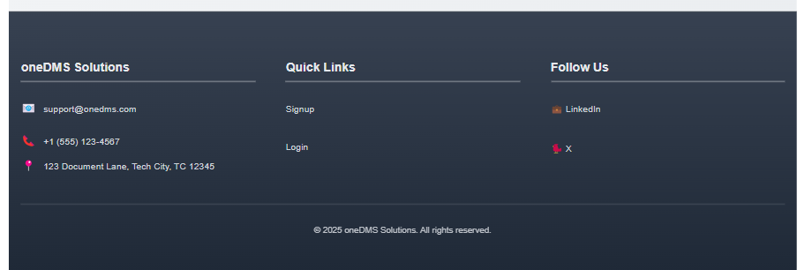

The home page welcomes users to **oneDMS** with the title: **"Welcome to oneDMS"**

and the theme: **"A Smarter Way to Organize, Access, and Manage Your Documents."**

It highlights key features under the section **"Why Choose oneDMS?"**, including:

* **Role-based access:** Secure and customized access levels.
* **Smart filters:** Quickly locate relevant documents.
* **Favorites:** Pin frequently accessed files.
* **Comments and activity logs:** Collaborate and track document interactions.

Users can navigate to the **Login** or **Signup** pages from here.

**Login Page**

The **Login** page allows registered users to access their oneDMS accounts by entering:

* **Username**
* **Password**

It also provides a link to the **Forgot Password** page for account recovery in case users lose access credentials.

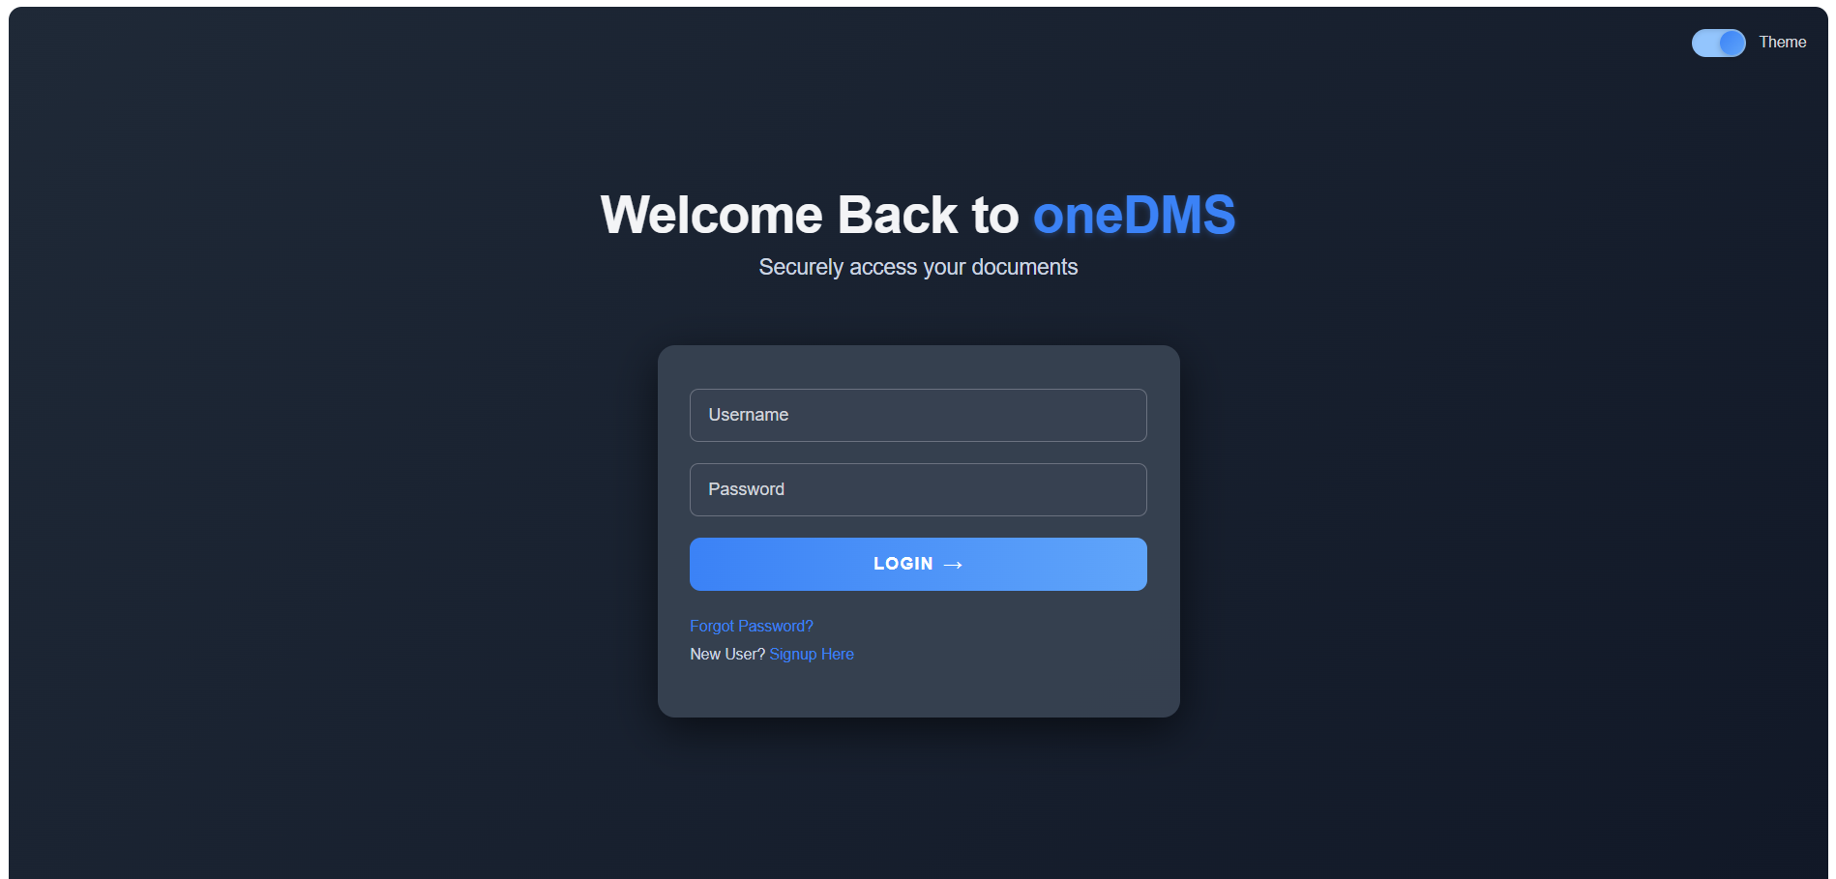

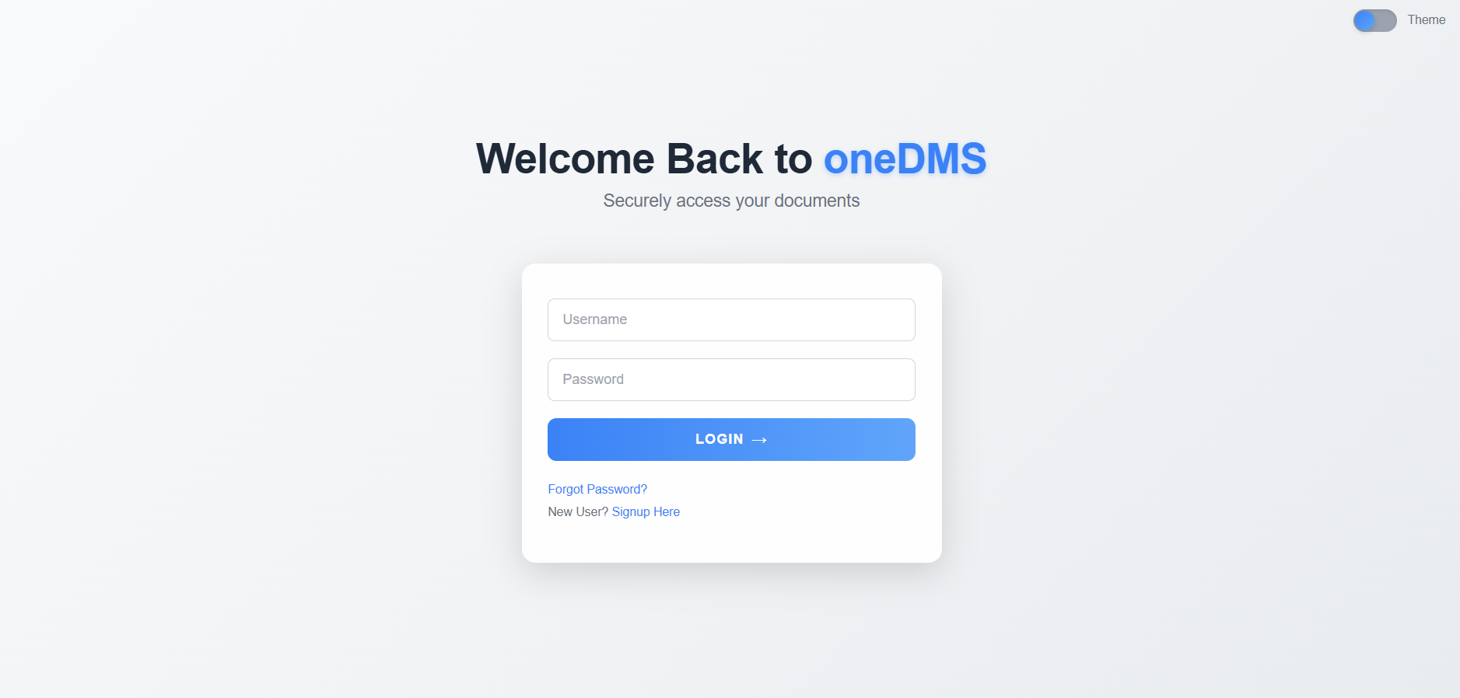

**Signup Page**

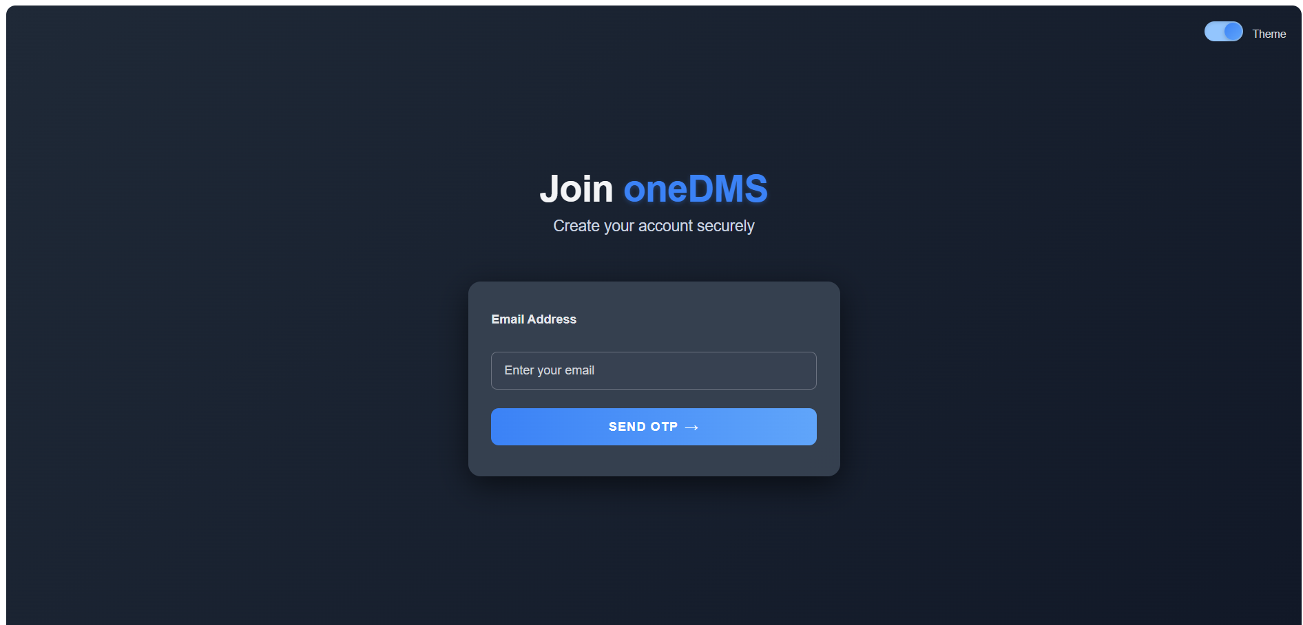

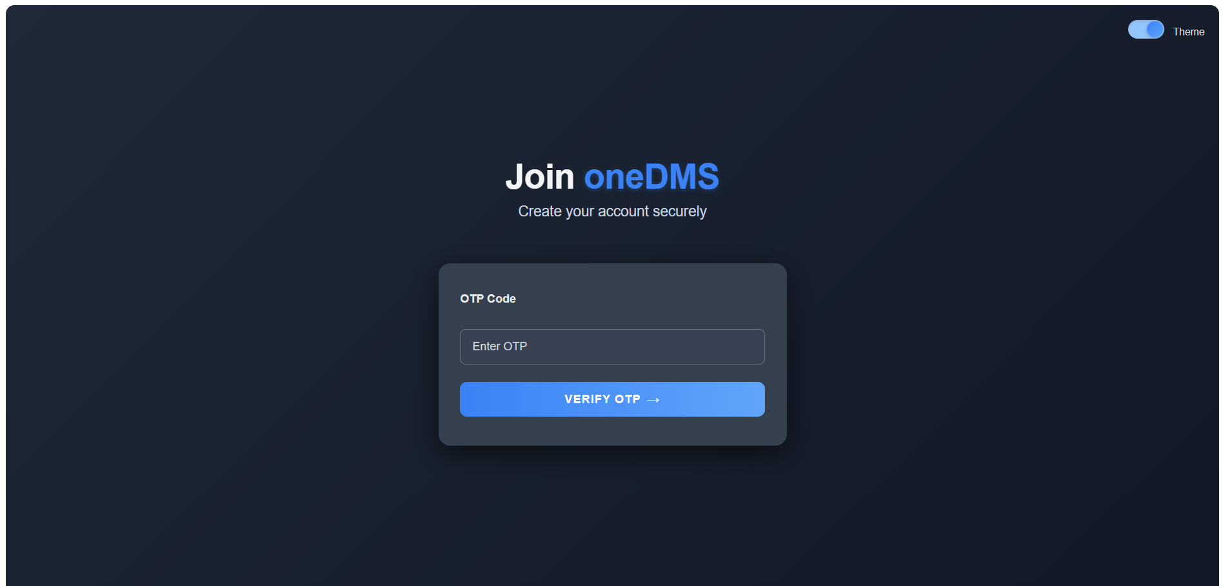 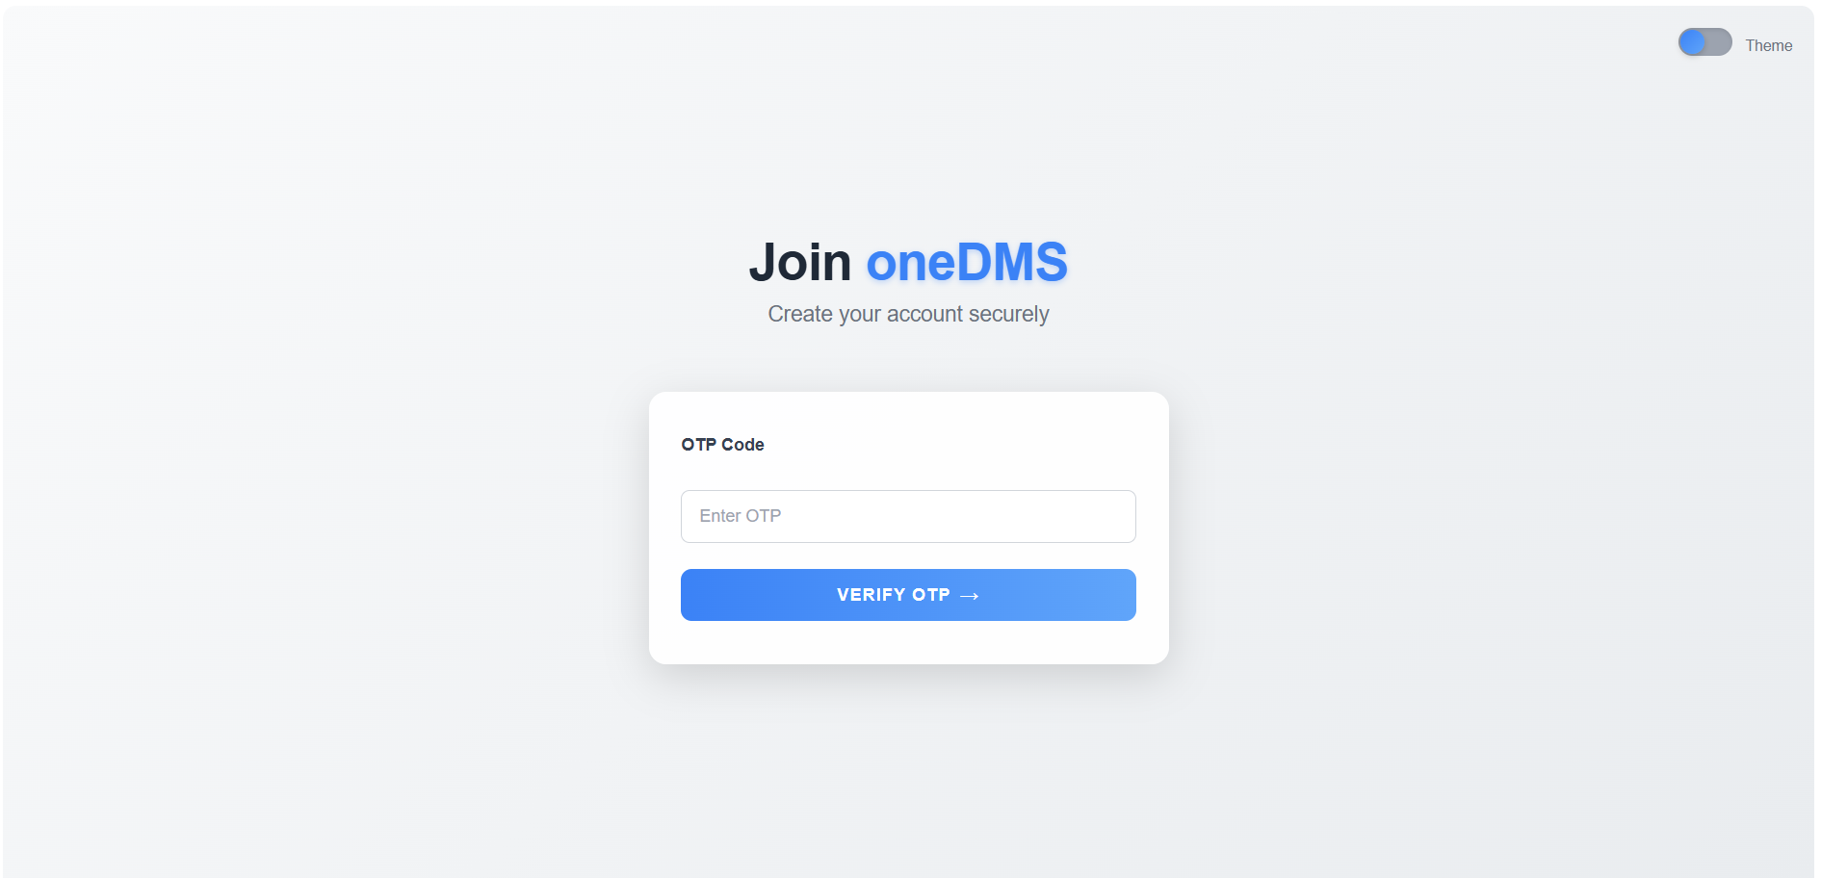 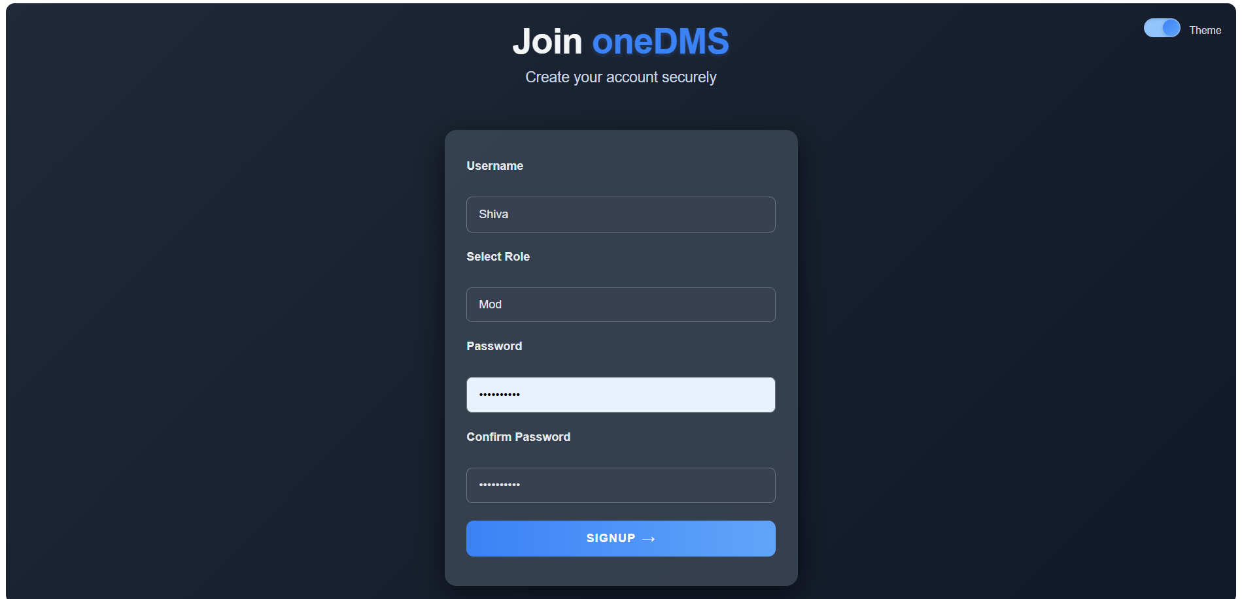 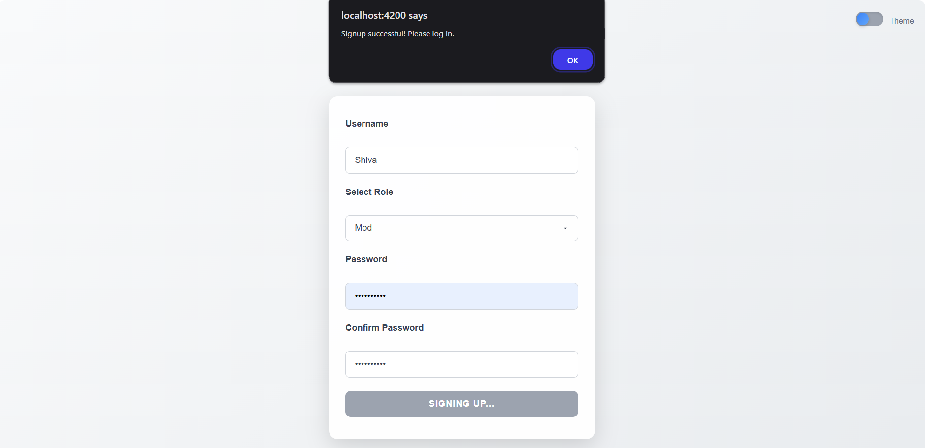  
The **Signup** page enables new users to create a oneDMS account by entering:

* **Name**
* **Email**
* **Password**

The page is accessible from the **Home Page** for first-time users.

**Forgot Password Page**

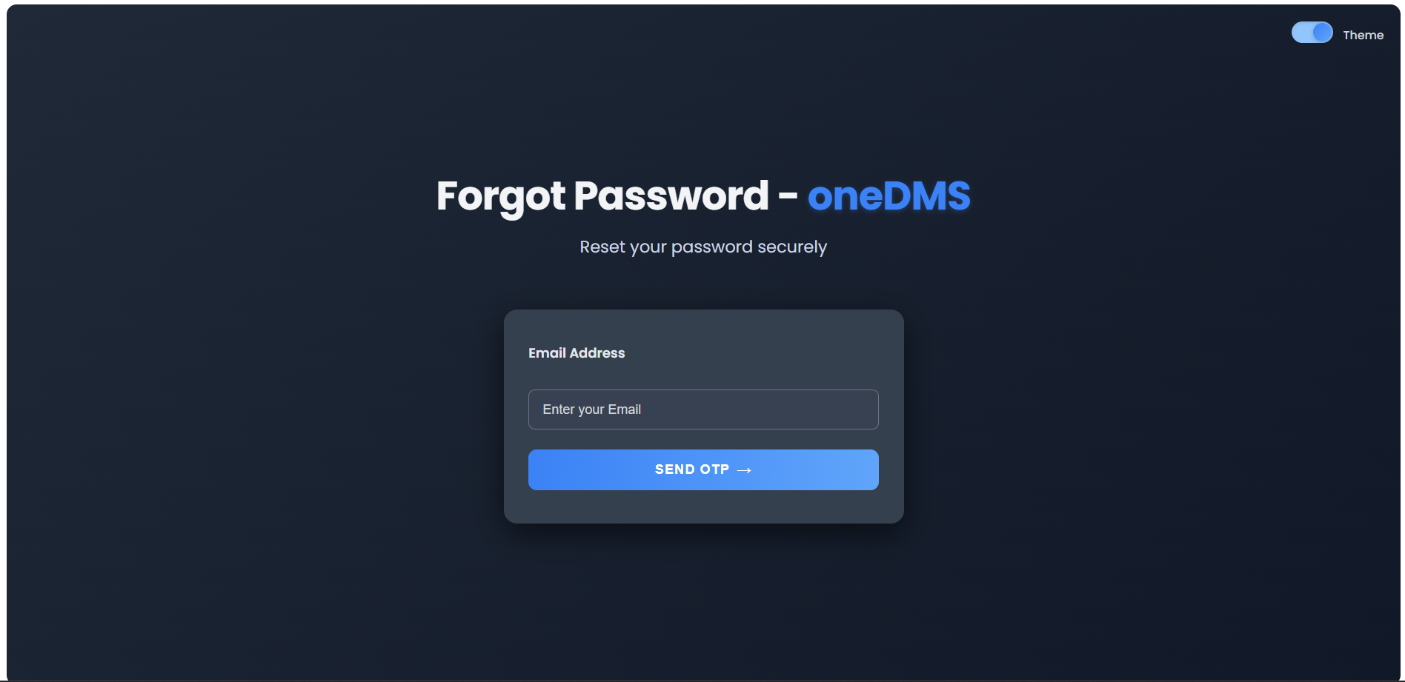 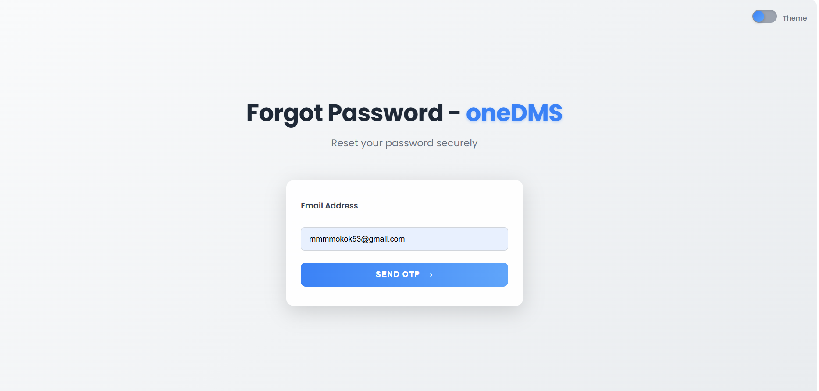 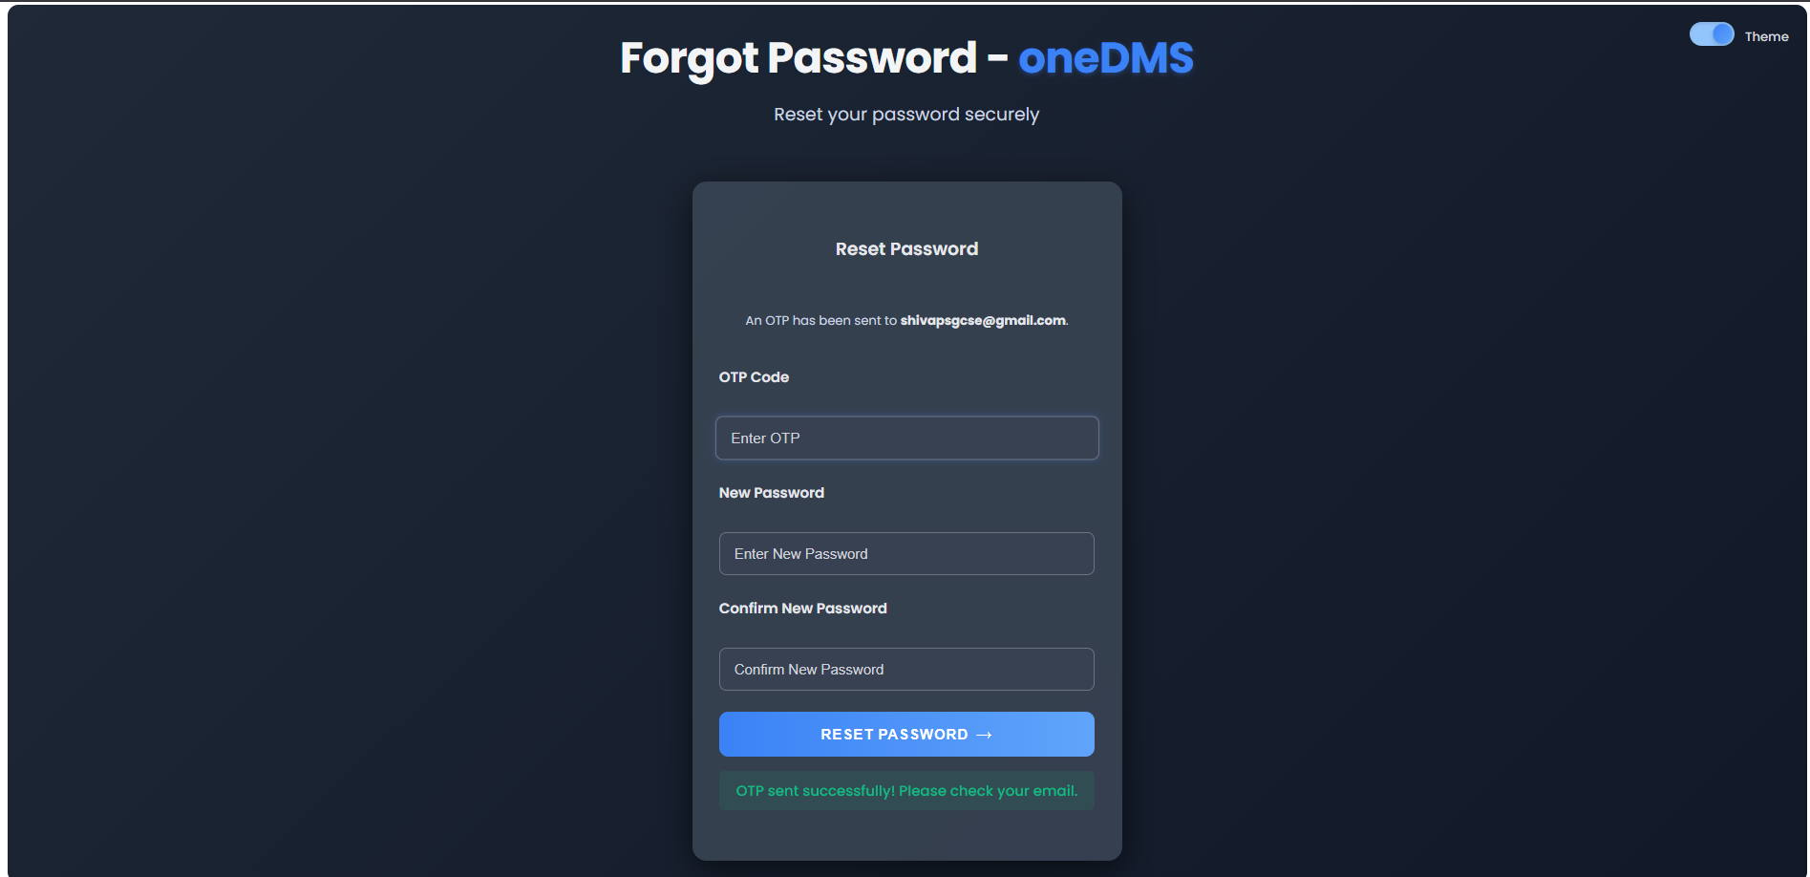 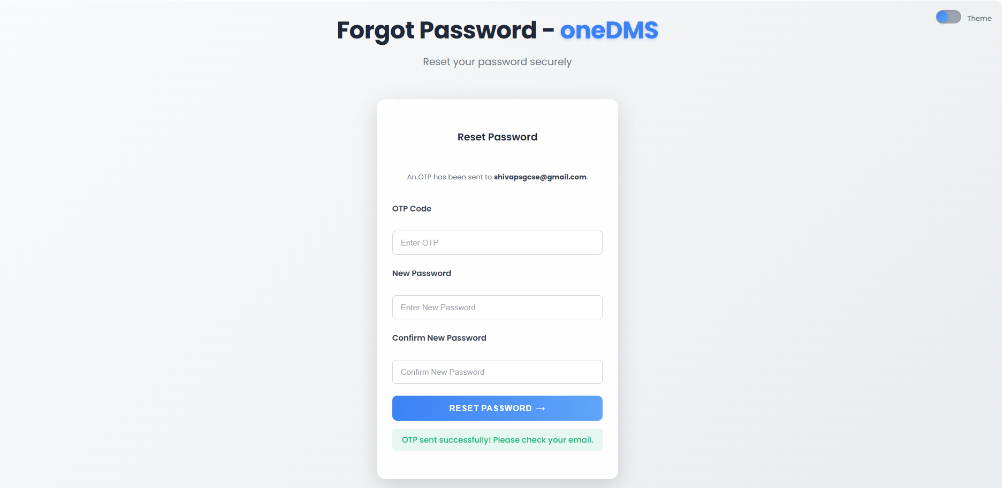

The **Forgot Password** page assists users in resetting their password by entering their:

* **Registered email** or
* **Username**

It sends a **reset link** or recovery instructions to the provided email for account recovery.

**DMS Application Page**  
The **DMS Application Page** serves as the main hub for managing documents. It offers:

* **Audit log:** Tracks document activities.
* **Admin panel:** For managing users and settings.
* **Smart filters:** Efficient document organization.
* **Favorites:** Quick access to frequently used files.
* **Comments:** Collaboration and annotation capabilities.

